***JAYAM COLLEGE OF ENGINEERING AND TECHNOLOGY***

***PROJECT NAME: SMART BILLING SYSTEM FOR***

***WATER SUPPLIERS***

***TEAM ID :NM2023TMID13375***

TEAM LEADER : RAGULGANDHI S

**TEAM MEMBER :PALANI M**

**TEAM MEMBERS:MUNIYAPPAN M**

TEAM MEMBERS:MURUGESAN N

NAAN

MUDHALVAN

PROJECT

INTRODUCTION:

PROJECT OVERVIEW:

***Nowadays several fill stations are set up across the cities to operate water tanker service delivering water to all the local households. Tankers get registered and a card is issued for the users which can be used for payments. They can also top-up their card through the mobile application. Each fill station is equipped with hand-held devices (based on the number of pumps in the fill station). These hand-held devices have the facility to read/write into RFID based smart cards as well as WIFI modem to communicate with the central server over the cloud. This data can then be viewed by the users on their respective mobile applications connected to the cloud.***

***Technical Architecture:***

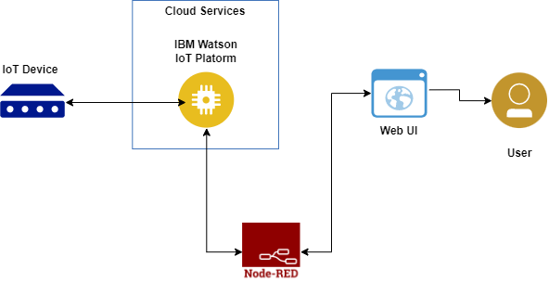

***PROJECT OBJECTIVES***

***By the end of the project, you will:***

* ***Gain knowledge of Watson IoT Platform***
* ***Explore Wokwi Platform***
* ***Explore the devices and its simulation of the wokwi platform.***
* ***Explore the libraries present in Wokwi.***
* ***Will be able to code to connect the devices across the cloud platform.***
* ***Connecting the devices on wokwi to the IoT platform device to exchange the sensor data.***
* ***Gain knowledge of creating devices and platforms using IBM Watson IoT Platform.***
* ***Gain knowledge of web application development through node-red.***

***PURPOSE:***

***The scheme involves the use of a variety of innovative features. Firstly, the use of High Density Polyethylene pipes that requires fewer joints makes for a more durable system as well as reduces the loss of water through leakages. Secondly ,the use of Automatic Meter Reading system has led to effective water auditing possible at any point of time and with cent per cent accuracy. Fig1.proposed System Block diagram(AWBS) This AWBS consists of a digital water flow rate sensor which is used to calculate amount of water consumed more accurately than the prevailing analog meters. Based on the amount of water consumed, bill is generated at the end of every month and an SMS is sent to the registered mobile number of the consumer. At the same time, this bill details are updated on the Water Board Server (Thingspeak Server) in our case), thus preventing delays in the process. Along with an SMS, notification through an APP and notification through an e-mail is also sent to the consumer. An APP is made available to the consumer where he can daily monitor the amount of water he has used and also access the online bill payment portal. Fig2.Block Diagram Of Data receiving and Processing Unit. In this project, Arduino UNO with an on board ATMEGA328P Microcontroller is used. The board has 14 input/output ports. 5V, 0.5A USB power supply powers the Board and a 12v, 2A Power Supply powers the GSM Module SIM900A. The Water Flow Rate Sensor used here is based on the working Principle of Hall Effect .The sensor we use here is YFS201 water flow rate sensor. GSM/GPRS module acts International Journal of Engineering Research in Computer Science and Engineering (IJERCSE) Volume 4, Issue 4, April 2017 55 ISSN (Online) 2394-2320 as interface for Arduino board to send an SMS as well as connect to the internet. Pin 2 of the Arduino Board is configured to act as an input, it receives the interrupt from the Water Flow Rate Sensor Thingspeak and Pushingbox are the cloud servers’ act as server for board and platform to send a Push Notification respectively The system implementation of the proposed design is illustrated in Figure 3 below: Fig3.prototype of the IOT based water monitoring system. V. EXPERIMENTAL RESULTS Data from Flow Rate Sensor : The Falling edges on the Signal Pin of the Flow Rate Sensor are input to pin 2 of Arduino board, which is configured to handle interrupts. 4.5 pulses are generated in one sec if the Flow Rate is 1l/min. The computation Logic, uses a calibration factor to Convert the Pulses count into Flow Rate i.e. L/min. The computation of Flow Rate is done for each day. The data for each day is uploaded onto the Thing Speak Server .After 30days, bill is sent as an SMS and a Push notification through Pushing Box. ThingSpeak is an open-source IOT cloud platform to store and retrieve data using HTTPotocol over internet. Pushing Box is a cloud that can send notifications based on API calls. From one request, you can send several notifications like a Push Notification, a Tweet, an Email, etc. The data for each day is uploaded onto the Thing Speak Server .After 30days, bill is sent as an SMS and a Push notification through Pushing Box***

**IDEATION&PROPOSED SOLUTION:**

***PROBLEM STATEMENT DEFINITION:***

**Administrators**

**Refers to the end-users of the system, the administrator side that control, maintain and routinely perform duties as to improve utilization of the proposed billing system.**

**Consumers/Stakeholders**

**Refer to the target users of the proposed web based billing and collection system.**

**Efficiency**

**A set of attributes that bear on the relationship between the level of performance of the software and the amount of resources used, under stated conditions – time behavior and resource utilization.**

**Functionality**

**Set of attributes that bear on the existence of a set of functions and their specified properties – suitability, accuracy, interoperability and security.**

**Graphical user interface (GUI)**

**A type of user interface that allows users to interact with programs in more ways than typing such as computers. A GUI offers graphical icons, and visual indicators, as opposed to text-based interfaces, typed command labels or text navigation to fully represent the information and actions available to a user. The actions are usually performed through direct manipulation of the graphical elements.**

**Internet**

**A global system of interconnected computer networks that use the standard Internet Protocol Suite (TCP/IP) to serve billions of users worldwide.**

**Maintainability**

**A set of attributes that bear on the effort needed to make specified modifications – analyzability, changeability, stability and testability.**

**Portability**

**A set of attributes that bear on the ability of software to be transferred from one environment to another – adaptability, installability, coexistence and replaceability.**

**Prototype**

**Refers to the original design of a portal to be presented to the stakeholders.**

**Quezon**

**A province of the Philippines located in the CALABARZON region in Luzon. The province was named after Manuel L. Quezon, the second President of the Philippines, and its capital is Lucena City. Quezon is located southeast of Metro Manila and it is surrounded by the provinces of Aurora to the north, Bulacan, Rizal, Laguna and Batangas to the west and the Camarines provinces to the east. Quezon lies on an isthmus separating the Bicol Peninsula from the main part of Luzon. The province also covers the Polillo Islands in the Philippine Sea.**

**Reliability**

**A set of attributes that bear on the capability of software to maintain its level of performance under stated conditions for a stated period of time – maturity, fault tolerance and recoverability.**

**Simplicity**

**The design of a website and all of its components wherein it is easy to explain, to understand in contrast with the word complicated.**

**Software**

**Refers to the program itself to be used in developing a website and its components**

**Usability**

**Refers to the elegance and clarity with which the interaction with a computer program or a web site is designed**

**Web-based billing and collection system**

**The proposed system that will serve as record keeping and monitoring system for the administration and end-users of the proposed real-time billing system.**

**Website**

**A collection of related web pages, images, videos or other digital assets that are addressed relative to a common Uniform Resource Locator (URL), also refers to the site on the internet wherein the researcher intends to develop the system.**

**The study was deemed significance according to various readings of the researcher, some of them were “Freedom of connection with any application to any party is deep fundamental social basis of the internet. And now is the basis of the society to build on the internet. I hope the United State Congress can protect net neutrality, so I can continue to innovate in the internet space. I want to go on seeing the huge amount of innovations which are happening out there and which is so diverse and so exciting. I want to see that continue innovated. It is very important to avoid a short term corporate grid in trying to get a short term return of investment by thinking that you can make a small proprietary market that you keep with yourself because in fact what you will do is you may block the creation of a huge market” [**[**3**](https://knepublishing.com/index.php/Kne-Social/article/view/2371/5222)**]. This idea and proposition of Mr. Berners-Lee led to the explosion of vast information using the World Wide Web. Berners-Lee launched the World Wide Web Foundation in order to advance the web to empower humanity by launching transformative programs that build local capacity to leverage the Web as a medium for positive change. This is another breakthrough in information technology as well as to the e-commerce industry bringing people together longing for a positive change not only in business but in some other aspects as well.**

**The City of Goose Creek [**[**27**](https://knepublishing.com/index.php/Kne-Social/article/view/2371/5222)**] provides water service to almost 9,000 customers. Residents may visit City Hall or call 843-797-6220, ext. 0 to open an account. In order to open an account over the phone, residents must have a Visa, MasterCard, or American Express credit or debit card. The system also provides paperless billing, direct debit and online payment. The direct debit service is provided at no charge. Payments will be automatically debited from your account each month.**

**In a field note titled “Developing Effective Billing and Collection Practices” [**[**1**](https://knepublishing.com/index.php/Kne-Social/article/view/2371/5222)**] states that improving billing and collection activities has an immediate impact on the revenue streams of a service provider that can, in turn, encourage commercial and operational efficiencies for aiding the expansion and delivery of improved, reliable, and sustainable services.**

**Effective billing and collections systems are a critical component for ensuring the viability of a service provider that can, in turn help the service provider in improving services. However, while effective billing and collections practices depend on many internal factors (including customer databases, the extent of metered and unmetered service provision, tariff and billing structures, delivery of bills, and facilities for customer payments), the institutional arrangements under which service providers operate and provide services determine whether such practices will remain sustainable in the long term. Efficient billing and collection practices can set incentives for the provider to effectively charge and collect water bills while also fulfilling a commercial orientation to services.**

**Spot Billing Machine, a handheld computer in which the program is stored along with all the relevant data, for issue of electricity bills, right at the customer premises, immediately after the meter reading is read and input to Spot Billing Machine [**[**21**](https://knepublishing.com/index.php/Kne-Social/article/view/2371/5222)**]. This features; immediate bill generation, collection of dues, through non-cash instruments, is performed in the field, variety of reports can be prepared such as utility bill with all relevant details, receipts against the bill, day end collection report and duplicate receipt.**

***EMPATHY MAP CNAVAS:***

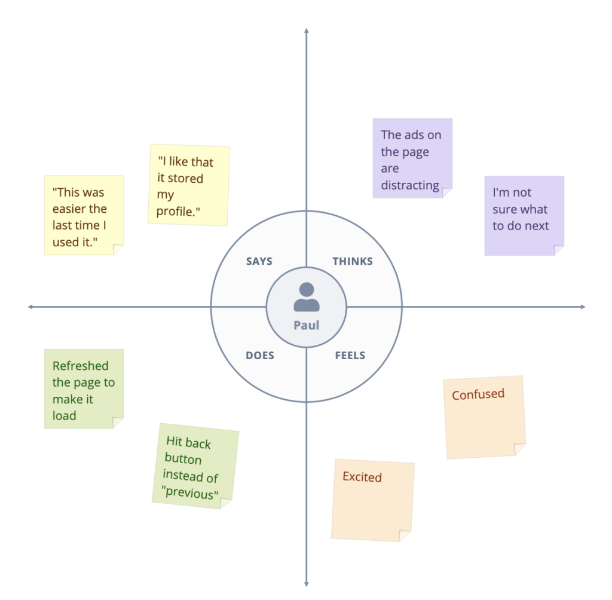

***Fig 1.01 : empathy map canvas.***

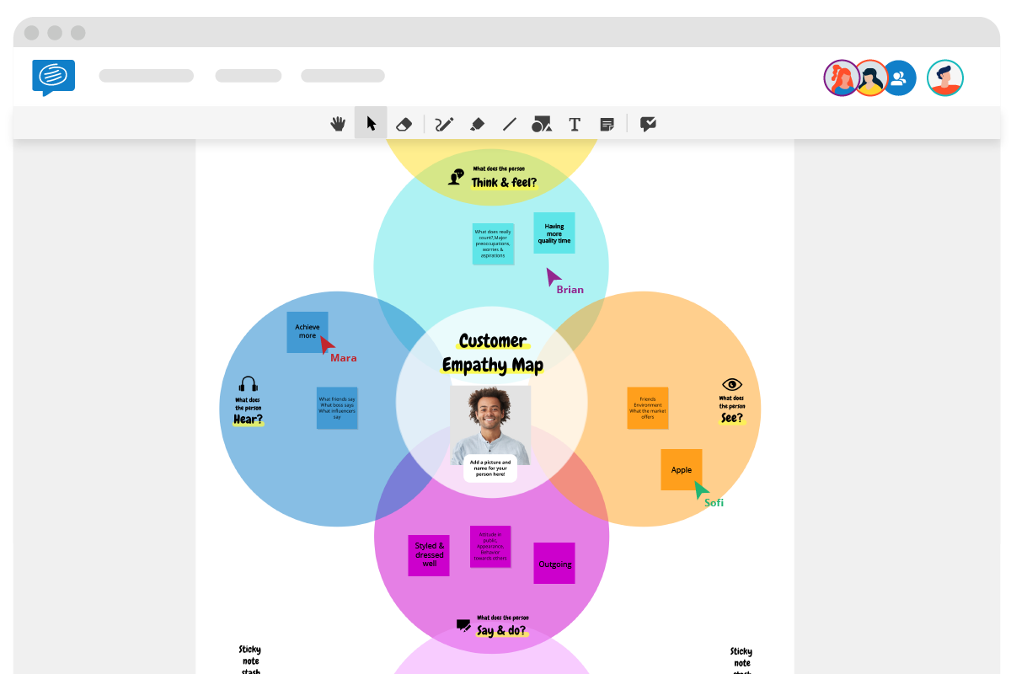

***fig 1.02 :empathy map canvas.***

1. ***While you can complete it alone, you’ll get much deeper insights if you can do it as a collaborative activity. That way everyone involved will benefit from understanding your customer better. Book a meeting slot (we recommend an hour), then invite team members from different departments by sending them a link to the board.***
2. ***Go through each of the six sections and encourage everyone to add at least one***[***sticky note***](https://conceptboard.com/blog/online-sticky-notes/)***in each quadrant based on their customer knowledge or experience.***
3. ***Return to each section and delve deeper or consolidate thoughts until you have a succinct collection of customer traits in each section.***
4. ***Once you’ve finished, you can share the completed board by downloading it as an image or a PDF***.

**Proposed solution:**

;

**MS withouOur proposed system is an electronic billing system to enhance these issues by using smart water meters. Each smart meter will send the monthly water meter readings corresponding to user’s water consumption. Once the water consumption is received an acknowledgement will be sent to the user as an SMS notification and then saved in the database of the water institution automatically. Once the database is completed the user will receive his invoice through message and hence paper bills are not required. 2. Proposed system Fig. 1. Proposed system block diagram Fig. 1, shows proposed system block diagram. The block diagram gives us an idea of how the system is going to work. The water meter has a water flow sensor used to sense the flow of water. The sensor sits in line with your water line, and uses a pinwheel sensor to measure how much liquid has moved through it. There is an integrated magnetic hall effect sensor that outputs an electrical pulse with every revolution. A turbine wheel embed with magnet is placed on a closed plastic envelop. When the water flows through the pipeline, it makes the turbine wheel to rotate and hence the magnet flux interferes the hall Automated Water Billing System Swati Jagtap1 , Mrunmayee Ladkhedkar2 , r. Ph probe measures ph by measuring the voltage or potential difference of solution in which it is dipped. By measuring the potential difference, hydrogen ion concentration can be calculated using the Nernst equation. The microcontroller will play a major role in regulating and giving the final outputs to the respective user in the form of SMS and LCD display. The monthly water consumption is sent wirelessly to the base station. The receiving mobile phones at the base station receives the monthly consumption. Hence the bills are created automatically and sent to the user through St human interference.**

**Requirement analysis:**

**Functional requirement:**

**BillMaster is a complete Computer Information System (CIS) for billing and management program which includes service orders, meter maintenance history and scheduling in addition to the Customer Relationship Management (CRM) and billing process. BillMaster features customizable account records, flexible reporting options, and unlimited rate schedules and charge calculations. Complex rate structures are supported. Every facet of the billing process may be adjusted to meet the specific needs (Data We with all the necessary features for running a small business including unlimited rate schedules, meter reading verification, individual user security settings and much more (Redline Data Systems, Inc, 2011)**

**control the flow of power (Dudas, 2002). It allows monitoring and delivering electrical power in more efficiently and accurately (Freescale Semiconductor, Inc., 2011).Examples of electrical appliances are computers, mobile phone, printers etc. When the electrical appliances are inactive, the power will manage the system and able to turn off to a lowpower state automatically (Domingo & Landmann, 2010). The trend change for smart metering also affected the Asian region. Sichuan South Gas Compressor Company (SSGC) who is responsible for more than 80% of power networks in China announced huge investment in term of smart grid. Smart meters will be an integral part of these change programs. Advanced Metering Infrastructure (AMI) which utilizes two-way communications to enable real-time monitoring and control of energy use in residential, commercial, and industrial buildings will be an important tool for utilities to accomplish their smart grid objectives. According to a new forecast from Pike research group, China will represent more than three-quarters of the installed base of smart meters in Asia Pacific, and the government has declared plans to continue a large-scale meter deployment through at least 2020 (Ovel, 2011). Singapore is also competing in this technology, the authorities signed a deal to shift to advance metering. ST Engineering's electronics arm, ST Electronics, on 13th Sep, 2010 announced that its subsidiary, Telematics Wireless Ltd has been awarded a contract worth US$21.5m (about S$29m) by Arad Technologies Ltd (Arad) to supply Automatic Meter Reading (AMR) radio transceivers for Arad's DIALOG 3G AMR solutions. The supply cooperation agreement between Arad and Telematics Wireless takes effect immediately and extends to 2015 (Business News, 2010). Tenaga Nasional Berhad (TNB) isthe largest electricity utility company in Malaysia that providing excellent services to the customers. There are approximated RM71.4 billion worth in assets and approximately 28,000 staffs serve seven millions of customers. In order to raise the economic growth and develop the social in the country, TNB continues to lead the effort (TNB, 2011). It shows that Malaysia being a rapidly growing developing country towards adaptation of technologies. To adopt and change with changing technologies is a healthy approach to keep ourselves up dated. But if a careful analysis is not taken into consideration this change may result into drawbacks rather than making some solid contribution and achievement.**

**Project design:**

***Data flow diagram:***

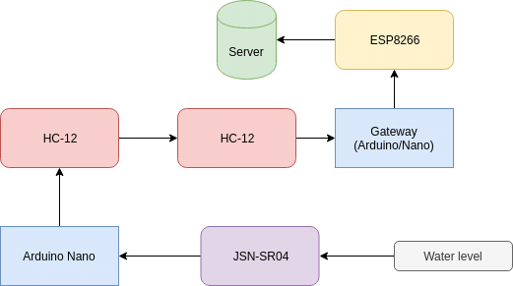

***Fig 1.014: data flow diagram***

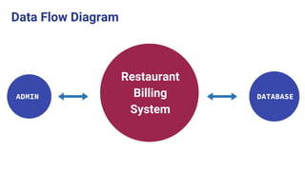

***Fig 1.015 : data flow diagram***

***UESRS STORIES:***

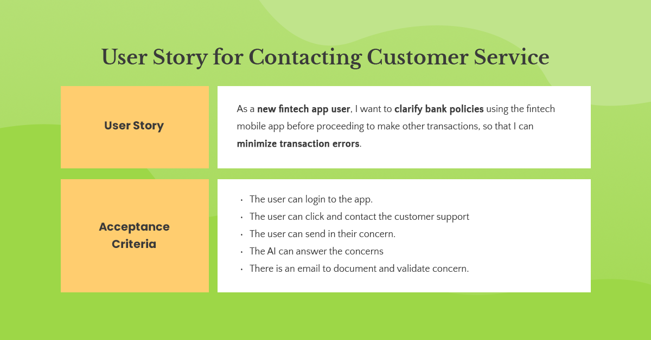

***Fig 1.016: user story for customer service***

**This research consists of several objectives as stated below: i. To develop an online system to manage electrical billing for the administrator and customer. ii. To collect the power consumption information and integrate with centralized database system via GSM device. iii. To calculate the electrical bill and generate a report on the power consumption information through online.**

**CODING& SOULTIONING:**

#include<conio.h>

#include<stdio.h>

#include<process.h>

#include<fstream.h>

//***************************************************************

// CLASS USED IN PROJECT

//****************************************************************

class product

{

int pno;

char name[50];

float price, qty, tax, dis;

public:

void create_product()

{

cout << "\nPlease Enter The Product No. of The Product ";

cin >> pno;

cout << "\n\nPlease Enter The Name of The Product ";

gets(name);

cout << "\nPlease Enter The Price of The Product ";

cin >> price;

cout << "\nPlease Enter The Discount (%) ";

cin >> dis;

}

void show_product()

{

cout << "\nThe Product No. of The Product : " << pno;

cout << "\nThe Name of The Product : ";

puts(name);

cout << "\nThe Price of The Product : " << price;

cout << "\nDiscount : " << dis;

}

int retpno()

{

return pno;

}

float retprice()

{

return price;

}

char * retname()

{

return name;

}

int retdis()

{

return dis;

}

}; //class ends here

//***************************************************************

// global declaration for stream object, object

//****************************************************************

fstream fp;

product pr;

//***************************************************************

// function to write in file

//****************************************************************

void write_product()

{

fp.open("Shop.dat", ios::out | ios::app);

pr.create_product();

fp.write((char * ) & pr, sizeof(product));

fp.close();

cout << "\n\nThe Product Has Been Created ";

getch();

}

//***************************************************************

// function to read all records from file

//****************************************************************

void display_all()

{

clrscr();

cout << "\n\n\n\t\tDISPLAY ALL RECORD !!!\n\n";

fp.open("Shop.dat", ios:: in );

while (fp.read((char * ) & pr, sizeof(product)))

{

pr.show_product();

cout << "\n\n====================================\n";

getch();

}

fp.close();

getch();

}

//***************************************************************

// function to read specific record from file

//****************************************************************

void display_sp(int n)

{

int flag = 0;

fp.open("Shop.dat", ios:: in );

while (fp.read((char * ) & pr, sizeof(product)))

{

if (pr.retpno() == n)

{

clrscr();

pr.show_product();

flag = 1;

}

}

fp.close();

if (flag == 0)

cout << "\n\nrecord not exist";

getch();

}

//***************************************************************

// function to modify record of file

//****************************************************************

void modify_product()

{

int no, found = 0;

clrscr();

cout << "\n\n\tTo Modify ";

cout << "\n\n\tPlease Enter The Product No. of The Product";

cin >> no;

fp.open("Shop.dat", ios:: in | ios::out);

while (fp.read((char * ) & pr, sizeof(product)) && found == 0)

{

if (pr.retpno() == no)

{

pr.show_product();

cout << "\nPlease Enter The New Details of Product" << endl;

pr.create_product();

int pos = -1 * sizeof(pr);

fp.seekp(pos, ios::cur);

fp.write((char * ) & pr, sizeof(product));

cout << "\n\n\t Record Updated";

found = 1;

}

}

fp.close();

if (found == 0)

cout << "\n\n Record Not Found ";

getch();

}

//***************************************************************

// function to delete record of file

//****************************************************************

void delete_product()

{

int no;

clrscr();

cout << "\n\n\n\tDelete Record";

cout << "\n\nPlease Enter The product no. of The Product You Want To Delete";

cin >> no;

fp.open("Shop.dat", ios:: in | ios::out);

fstream fp2;

fp2.open("Temp.dat", ios::out);

fp.seekg(0, ios::beg);

while (fp.read((char * ) & pr, sizeof(product)))

{

if (pr.retpno() != no)

{

fp2.write((char * ) & pr, sizeof(product));

}

}

fp2.close();

fp.close();

remove("Shop.dat");

rename("Temp.dat", "Shop.dat");

cout << "\n\n\tRecord Deleted ..";

getch();

}

//***************************************************************

// function to display all products price list

//****************************************************************

void menu()

{

clrscr();

fp.open("Shop.dat", ios:: in );

if (!fp)

{

cout << "ERROR!!! FILE COULD NOT BE OPEN\n\n\n Go To Admin Menu to create

File ";

cout << "\n\n\n Program is closing ....";

getch();

exit(0);

}

cout << "\n\n\t\tProduct MENU\n\n";

cout << "====================================================\n";

cout << "P.NO.\t\tNAME\t\tPRICE\n";

cout << "====================================================\n";

while (fp.read((char * ) & pr, sizeof(product)))

{

cout << pr.retpno() << "\t\t" << pr.retname() << "\t\t" << pr.retprice() << endl;

}

fp.close();

}

//***************************************************************

// function to place order and generating bill for Products

//****************************************************************

void place_order()

{

int order_arr[50], quan[50], c = 0;

float amt, damt, total = 0;

char ch = 'Y';

menu();

cout << "\n============================";

cout << "\n PLACE YOUR ORDER";

cout << "\n============================\n";

do

{

cout << "\n\nEnter The Product No. Of The Product : ";

cin >> order_arr[c];

cout << "\nQuantity in number : ";

cin >> quan[c];

c++;

cout << "\nDo You Want To Order Another Product ? (y/n)";

cin >> ch;

} while (ch == 'y' || ch == 'Y');

cout << "\n\nThank You For Placing The Order";

getch();

clrscr();

cout << "\n\n******************************** INVOICE ************************\n";

cout << "\nPr No.\tPr Name\tQuantity \tPrice \tAmount \tAmount after

discount\ n ";

for (int x = 0; x <= c; x++)

{

fp.open("Shop.dat", ios:: in );

fp.read((char * ) & pr, sizeof(product));

while (!fp.eof())

{

if (pr.retpno() == order_arr[x])

{

amt = pr.retprice() * quan[x];

damt = amt - (amt * pr.retdis() / 100);

cout << "\n" << order_arr[x] << "\t" << pr.retname() <<

"\t" << quan[x] << "\t\t" << pr.retprice() << "\t" << amt << "\t\t" << damt;

total += damt;

}

fp.read((char * ) & pr, sizeof(product));

}

fp.close();

}

cout << "\n\n\t\t\t\t\tTOTAL = " << total;

getch();

}

//***************************************************************

// INTRODUCTION FUNCTION

//****************************************************************

void intro()

{

clrscr();

gotoxy(31, 11);

cout << "SUPER MARKET";

gotoxy(35, 14);

cout << "BILLING";

gotoxy(35, 17);

cout << "PROJECT";

cout << "\n\nMADE BY : ANUJ KUMAR";

cout << "\n\nSCHOOL : RYAN INTERNATIONAL SCHOOL";

getch();

}

//***************************************************************

// ADMINSTRATOR MENU FUNCTION

//****************************************************************

void admin_menu()

{

clrscr();

char ch2;

cout << "\n\n\n\tADMIN MENU";

cout << "\n\n\t1.CREATE PRODUCT";

cout << "\n\n\t2.DISPLAY ALL PRODUCTS";

cout << "\n\n\t3.QUERY ";

cout << "\n\n\t4.MODIFY PRODUCT";

cout << "\n\n\t5.DELETE PRODUCT";

cout << "\n\n\t6.VIEW PRODUCT MENU";

cout << "\n\n\t7.BACK TO MAIN MENU";

cout << "\n\n\tPlease Enter Your Choice (1-7) ";

ch2 = getche();

switch (ch2)

{

case '1':

clrscr();

write_product();

break;

case '2':

display_all();

break;

case '3':

int num;

clrscr();

cout << "\n\n\tPlease Enter The Product No. ";

cin >> num;

display_sp(num);

break;

case '4':

modify_product();

break;

case '5':

delete_product();

break;

case '6':

menu();

getch();

case '7':

break;

default:

cout << "\a";

admin_menu();

}

}

//***************************************************************

// THE MAIN FUNCTION OF PROGRAM

//****************************************************************

void main()

{

char ch;

intro();

do

{

clrscr();

cout << "\n\n\n\tMAIN MENU";

cout << "\n\n\t01. CUSTOMER";

cout << "\n\n\t02. ADMINISTRATOR";

cout << "\n\n\t03. EXIT";

cout << "\n\n\tPlease Select Your Option (1-3) ";

ch = getche();

switch (ch)

{

case '1':

clrscr();

place_order();

getch();

break;

case '2':

admin_menu();

break;

case '3':

exit(0);

default:

cout << "\a";

}

} while (ch != '3');

}

***RESULTS:***

**On the basis of analysis and design, the system provides a smart water meter with eco- friendly and energy efficient system. As the smart water meters are digitized and automated, high accuracy is maintained by decreasing human efforts. Water theft can be avoided since there are no mechanical parts that can be subjected to tamper.A flow sensor based water metering system was used for automated billing, eliminating the drawbacks of traditional water metering systems. Further, multiple houses in a building could use separate end nodes with a common gateway connecting to the internet for accurate billing based on individual consumption of houses. An analysis of water usage through various outlets in a house was provided in order to educate residents on cutting down wasteful usage. This paper demonstrates the successful implementation of an internet-based approach to monitor water supply and usage on a real time**

***VIDEO DEMO LINK:***

[***https://www.youtube.com/watch?v=_TN94lBFI1s***](https://www.youtube.com/watch?v=_TN94lBFI1s)

[***https://www.youtube.com/watch?v=X2cuektqZx0***](https://www.youtube.com/watch?v=X2cuektqZx0)